Elan Johnson

17207391

SMGT 20070: Sport Tourism

2008 Beijing Summer Olympics: An Intricate ‘Bird’s Nest’ for Sports Tourism

In July of 2001, seven long years before the 2008 Summer Olympic Games would kick off, the International Olympic Committee (IOC) voted in favor of having China’s political capital of Beijing host its’ first ever Olympic Games. This was only the third time an Asian country has hosted any Olympic Games: Tokyo hosted in 1964 and twenty years before 2008, Seoul hosted the games in 1988 (China Business Review, 2008). Winning the bid to host the costly yet prestigious sports event gave China an opportunity to show the rest of the world how developed and modern the East Asian country had become in the past several years.

Seven years after the initial announcement, the 2008 Summer Olympic Games were held in Beijing, which had a total of thirty-seven sporting venues alone for this magnificent sporting spectacle. Thousands of athletes poured into the traditional and modernized capital city to compete in the Games, and hundreds of international media immediately followed them to bear witness to China’s display of hosting excellence. After two weeks filled with many medal ceremonies, fireworks, and world records, the Olympic Games ended as all others do. Now a decade since the games were held in China, there have been five more games to compare the Beijing games to. Most of them have failed or did not make enough revenue to justify the billions in costs to host. The costly 2014 Sochi Winter Games completely failed. Rio De Janeiro, a city which once had large economic growth and potential, instead produced a controversial Summer Games. Based on these two games, Beijing’s 2008 Games looks to have been a success and great investment for China’s economic and sports tourism future. However, with more research and inspection of the “successful” games, these Olympics held in China did not actually reap as many benefits as previously thought. Hosting the summer games catapulted Beijing onto the international stage and greatly improved the city’s infrastructure. However, the social, political, and economical costs of the games prove that the billions of dollars’ investment now seems to be quite overestimated in its benefits to Beijing and China overall.

In this paper, I will first discuss the main reasons why some people say the Beijing Summer Olympics in 2008 were deemed a success, mostly due to the heightened media attention towards China and improvements to the city’s infrastructure. Following this, I will dive into the actual costs of hosting the games by briefly looking at Doxey’s Irridex and providing social, political, and economical examples that prove the investment was very overestimated. The paper will then conclude by examining the 2022 Beijing Winter Olympics and offering potential improvements China can make in order to justify hosting the Olympics for a second time.

Being only the third Asian country to host an Olympic Games, winning the bid to organize the 2008 Summer Games brought Beijing and China onto the world stage it had not had previously. After the economy was opened after decades of closure from international trade and influence, China’s major cities and economy had been developing rapidly. Hosting the 2008 Olympics gave the country an opportunity to bring the changing and modernizing country to prominence. One of the ways Beijing attracted so much attention during the Olympic Games was due to the higher amount of media and journalists present. News outlets such as BBC, CNN, CCTV, and America’s own NBC were allowed to cover the sporting events during the two weeks the games were held, and a total of 24,600 accredited media and press broadcasters were in Beijing during the Olympics (Appendix A). In a media coverage study done during the Olympics, it showed that over 14% of the top American news agencies talked about China and the Games (Phillippe Bovy, 2009). While this percentage may seem low, during the summer of 2008, in America there was a major presidential election, which took up a larger percentage of news coverage. NBC tripled its coverage on the Beijing Olympics and 48% of their daily stories related to the games or were about Beijing. In the two weeks leading up to the games alone, 18% of the stories were about China’s intense preparation to host the summer games and their excitement about the record breaking opening ceremonies (Pew Research Center, 2008). Along with the United States, Europe was keen to focus on Olympic coverage and shed light on China has the host nation. BBC, which had exclusive rights to broadcast the Olympics, offered twice as much coverage as it did for the last Olympics in 2004. This translated into over 3,000 hours of Olympic television coverage, and 300 hours of high definition coverage for European fans to watch their favorite sports and athletes in better quality (The Guardian, 2008). Due to the large time difference between China and other Western countries, the sporting events at the games were shown longer and to more people worldwide, which helped China gain more news coverage overall.

Another unplanned yet critical factor into China’s increase in media attention during the Olympics was from record breaking athletes who dominated the games. Usain Bolt and Michael Phelps, the latter being the most talked about athlete during the games across all countries, solely produced 26.6% of the U.S.’s coverage of the Olympics (Appendix B, Pew Research Center, 2008). Michael Phelps won a total of eight Olympic gold medals in Beijing, which in Chinese culture, is the luckiest number. His dominance in the swimming competitions held in the Aquatic Center in Beijing helped bring in more media attention and news coverage. Though the focus may have been on the athlete, Phelps still shattered world records and made history in the city of Beijing for all the world to see. Usain Bolt, an elite Jamaican track and field runner, also won three gold medals at the Olympics. He earned a new world record for those three events, which was all done in the excitedly packed Bird’s Nest with millions of fans watching.

With the increased media coverage and record breaking by athletes that helped fill televisions with exciting stories, the 2008 Summer Games became the most watched Olympics ever. A total of 4.7 billion people watched the games, which was a 21% increase from the 2004 Athens games which had 3.9 billion watching (Appendix C). This meant that over 70% of the world’s total population watched the Olympics in some shape or form; meaning that over three quarters of the world saw events or stories related to China and Beijing. Not only did the world take part in watching Beijing host the Olympics, but 94% of the Chinese population viewed the games (Nielsen, 2008). This significant number shows that heightened media attention and large percentage of viewership partly created the opinion that the Olympics were indeed successful.

Another reason as to why people perceive Beijing’s 2008 Games as being justified is the city’s infrastructure development. Hosting the largest sporting event in the world requires modernized transportation systems, sporting venues, practice facilities, and the Olympic Village for athletes. After China won the bid to host in 2001, improving the city’s infrastructure, which included roads, highways, subway systems, and buildings was the government’s number one priority to make these games run smoothly. Over the next several years, the city of Beijing spent nearly $40 billion dollars on infrastructure leading up to the games (China Business Review, 2008). Part of this investment went towards updating the Beijing subway system, which went from three lines in 2002 to seven lines for the Olympics, providing 75% of accessibility to the Olympic venues (Phillippe Bovy, 2009). Regarding the improvements of roads in the city of Beijing, the government created 300 kilometers of continuous Olympic lanes for athletes and other participants to gain access to the venues at a faster rate during rush hour traffic (Appendix D). Beijing’s famous ring road system was expanded hundreds of kilometers. The international airport was tripled to provide an influx of 75 million passengers, which could support only 25 million passengers in 2002. Closer to the opening of the games, the city developed Beijing’s bus system by providing 20,000 buses for residents and tourists to get across the city easier (Phillippe Bovy, 2009). The Chinese government, spending billions of dollars to host the Olympics, put infrastructure at the top of their agenda to create a modernized transportation system that would compete with other developed cities.

Beijing also completely updated or built 37 Olympic venues for the games, which ranged from the famous Bird’s Nest all the way to a shooting range hall. The Bird’s Nest, which hosted the opening and closing ceremonies, was the shining spectacle of the Olympics. Along with the nearby Aquatic Center, this venue is the most famous of the many venues that held sporting events in 2008 (Travel China Guide, 2010). The Bird’s Nest and Aquatic Center are now famous landmarks in Beijing, and millions of tourists every year tour the site that witnessed Usain Bolt break three world records and Michael Phelps win eight gold medals. While the Olympic venues in Sochi and Rio were mostly all torn down, the Bird’s Nest is still standing and continues to be a famous landmark in China. Currently, these two venues serve as a reminder of the 2008 games, how it brought great national pride and international attention to Beijing, and makes people think of the Summer Olympics as a sporting event that greatly benefited China.

While Beijing’s international recognition and strengthened infrastructure created a popular opinion that the 2008 Summer Olympics was a success, the games had several social, political, and economic debacles that actually tainted the game’s legacy. In terms of social aspects, China initially announced that all international media would have freedom of speech and could write anything about the games. Unfortunately, this was not the case, and the Chinese government swiftly banned several reporters from entering the country or documenting the Olympics due to their negative views about the host country. Images of Tiananmen Square, which China linked to the 1989 massacre, were immediately banned from any television broadcasts, and journalists were mandated to have an escort in venues in order to document the games, even though this was never fully enforced (Washington Post, 2009). Used to some independence or free reign, international media were stunned by the government’s new rules and strictness on freedom of speech. For a certain period of time during the games, BBC and Amnesty International were blocked from computers, which created an even larger backlash against the government (Postmark Beijing). One French reporter was even forcefully put into a van while covering a small protest in Beijing, further outraging the European media who were already angry at the social injustice that they felt was happening during the Olympic Games (Washington Post, 2009).

China also stated that during the Olympic Games, in order to control social protests, the government would set up three specialized “protest zones” in public parks. This way, people could protest peacefully in a controlled manner which would not overshadow the heightened media attention with the Games taking place. Communist in nature however, the Chinese government instructed that all potential protestors needed to seek approval from officials in order to demonstrate (Maureen Fan, 2008). No protests were approved by the government, and most organizations wanting to protest ended up not applying for fear they would face political backlash or even arrest. Some people without permits who came to the protest zones in downtown Beijing were forcibly removed or arrested. The failure of the Chinese government to maintain its promise for basic human rights to protest and have freedom of speech was not heavily publicized in the media. Yet, it put a damper on many local Chinese’s hopes that the international prominence the Olympic Games created for China would in turn establish a new standard for basic social human rights.

Politically, many people thought that the Chinese government did little to settle its long going discord with autonomous regions in the area like Tibet and Xinjiang. China’s strict, opposing views on independence from the mainland created many protests from Tibetans and other domestic Chinese. When Beijing first won the bid to host the Olympic Games, the government repeatedly reassured the International Olympic Committee that they were working with these groups to come to a compromise or create peace with one another leading up to the 2008 Games. This unfortunately did not happen, and China arrested many protesters, diminished Tibetans human rights, and created unfair governmental policies (China Business Review, 2008). In response, there was much violence in Tibet in the months before the games, and hundreds were killed or injured after police tried to end a Tibetan protest from continuing (Economy & Segal, 2008). China faced immediate backlash from other political news groups and leaders, who opposed the government’s handling of the situation, which escalated further when journalists covering the story were detained and officials closed off Tibet from the rest of world. Countries were also angered by China’s heavy involvement with Sudan Darfur, as China reportedly gave the Sudanese government weapons and supplies to aid them in their military efforts (Allison Welch, 2010). Political leaders and human rights organizations protested against this, as they believed China had broken the United Nation’s rules and were meddling in affairs that were not their own. Many thought about boycotting the 2008 Olympic Games because of China’s inability to create political peace and solve any of its domestic issues. During the Olympic torch carrying ceremony, as the torch came through various countries, thousands of people around the world protested against China and the government’s political policies. Protests occurred in over ten countries, which generated a very negative light on China leading up to the Beijing Games and were not forgotten after the Olympics were over.

After the games were over in August of 2008, many of the sport venues were demolished or left for the elements to take over. Though China spent over $40 billion dollars on infrastructure and the development of Olympic sized venues to host the games, many of the thirty-seven venues were considered obsolete. Many venues were left to rot, were vandalized, or are going to be demolished in the coming years (Appendix E). While the famous Bird’s Nest and Aquatic Center are some of the main tourist attractions in Beijing to this day, some of the other venues are not in use. The volleyball stadium, which held over 9,000 people, now is deserted and is covered in art. The rowing and canoeing park built specifically for the Olympics is now dried up and left alone (Justine Lopez, 2016). Economically, building so many venues for them to no longer be useful is extremely wasteful, and China did not get much return on investment for spending billions on these modern structures. Like many other Olympics, the costs to host the games outweighs the brand new buildings and sporting venues. Instead of using some of these venues for other sporting events or creating new purposes for them, Beijing wasted their money in order to show the world how modernized and wonderful the Summer Games would be.

Even though Beijing’s infrastructure was updated and modernized for the Olympics, this development also came at a high cost that cast a shadow over the games. In order to build new roads, subway systems, and venues to host a myriad of sports, the Chinese government had to find places in the city to build. Unfortunately, many of the Olympic areas were originally people’s homes and traditional hutongs that had been a part of Beijing’s culture since ancient times. Over 500,000 people were removed from their homes in order to make room for the modern infrastructure, though the Chinese government denied the numbers or any wrongdoing. The Chinese Foreign Ministry stated that only 6,000 residents were displaced but were given some form of compensation (Lindsay Beck, 2008). While Beijing residents were initially elated with China hosting the Olympic Games, as people began to be displaced for development, they became angry and annoyed by China’s plans to host. This example is closely linked to Doxey’s Irridex, which states that many locals experience four feelings with a new sports tourism area. While locals are at first euphoric over the idea that this increase in tourism will help the economy and local area, these feelings are slowly replaced with apathy, annoyance and finally antagonism towards the development (Sports Tourism Lecture, 2018). Many Beijing residents who ended up losing their homes initially were happy about the Olympics, but after the government forcibly removed them, several residents wanted to protest against the government. Along with other people wanting to protest the games, residents had to apply for a permit to protest (Allison Welch, 2010). In the end, this displacement situation did not end up on international media’s radar, and instead the media focused on the glory and glitz of the games.

After a country hosts a large sporting event like an Olympics, tourism can sometimes increase and more people may travel to visit. While an initial thought can be that Beijing’s tourism numbers increased after the 2008 Summer Olympics, this is quite the opposite. The number of international tourists travelling to China decreased after 2008 by a total of 2.73% from 13,002 (unit of 10,000 persons) to 12,647 (Travel China Guide, 2008). Numbers continued to decline by 1-2% several years following the Games, which shows that the Olympics did not help bring in tourism and did little to help grow tourism numbers (Appendix F).

Even though the investment of hosting the Summer Olympics is overestimated, Beijing is once again hosting another Olympics. Beijing will host the 2022 Winter Olympics, and plans to bring snow from surrounding areas and build three new venues for this event (Time, 2018). In order for Beijing to make any a return on investment and have hosting this $4 billion project justifiable, China needs to do several things different from the 2008 Games to make it successful. First, China should use mostly existing venues and build Olympic sporting places that can be taken down or used for other purposes. This way buildings are not left to sit and could improve the city’s modernization even further. Along with this, the Chinese government needs to try and handle its political and social issues in a less authoritarian way. Allowing some protests in zones and giving international media a larger range of accepted stories, while it could slightly take away from the games, would give people freedom of speech that many nations have criticized China for. While there are many other improvements Beijing could do to make the 2022 Games better than the previous ones, the Olympic Games overall is an investment that may never be justifiable.

While there were many benefits to hosting the 2008 Summer Olympic Games for Beijing, which include improved infrastructure and new media attention, the costs of the games outweigh the benefits significantly. Local Chinese and international media were denied freedom of speech, protestors were unable to voice their opinions, China’s political stances threatened their stability and relationship with other nations, people were displaced from their homes to make way for venues, and tourism numbers actually declined following the games. All of these social, political and economic aspects show that the investment in this large sporting event is unjustified and greatly overestimated.

References

Beck, Lindsay. “Beijing to Evict 1.5 Million for Olympics: Group.” *Reuters*, 5 June 2007.

“BEIJING OLYMPICS DRAW LARGEST EVER GLOBAL TV AUDIENCE.” Nielsen, 9 May 2008.

“Beijing 2008 Olympic Venues.” *Travel China Guide*, 2008.

Bovy, Philippe. “Beijing 2008 Olympic Games Success: Massive Public Transport Developments and Major Road Traffic Reduction.” *Mobility*.

Elizabeth C. Economy; Adam Segal, China's Olympic Nightmare - What the Games Mean for Beijing's Future, 87 Foreign Aff. 47 (2008)

Kiss, Jemima. “Olympics: BBC Promises 'Cornucopia of Content'.” *The Guardian*, 8 Aug. 2008.

Lopez, Justine. “PHOTOS: 2008 Beijing Olympic Venues - Then & Now.” *That's Magazine*, 10 Aug. 2016.

“Olympics Report Card: Success or Failure?” *Postmark Beijing*.

Sands, Lee M. “The 2008 Olympics’ Impact on China.” *China Business Review*

“China Tourism.” *Travel China Guide*, 2010.

“The Media’s Olympics.” *Pew Research Center*, 2008.

Welch, Allison. “Human Rights in China: 2008 Beijing Summer Olympics.” *Human Rights & Human Welfare*.

Appendix A

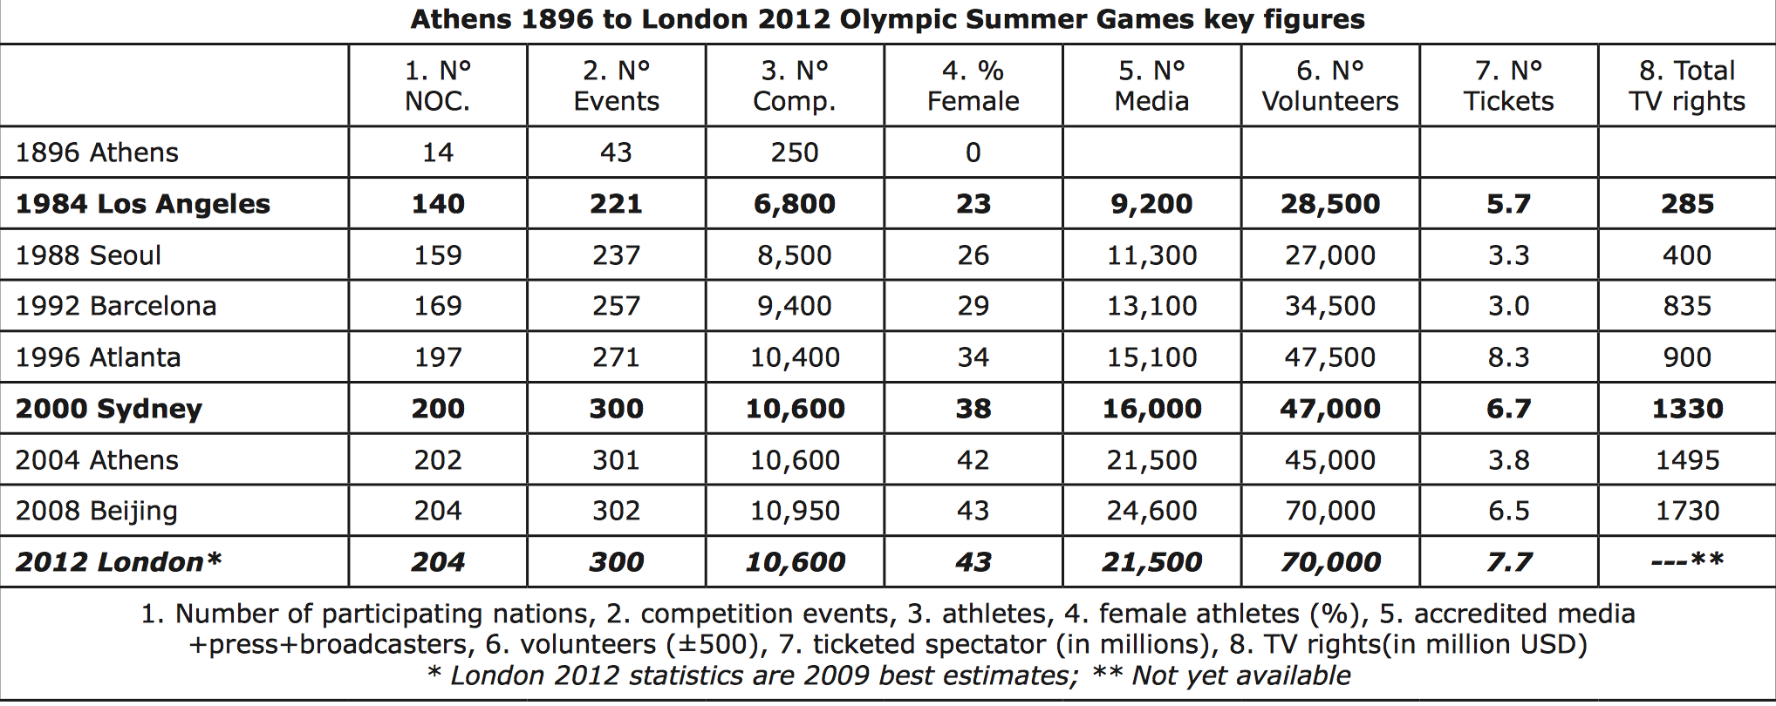

Appendix B

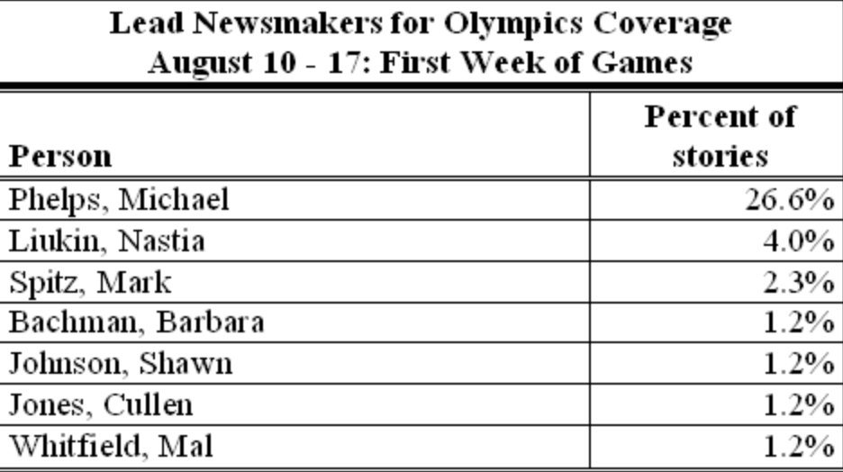

Appendix C

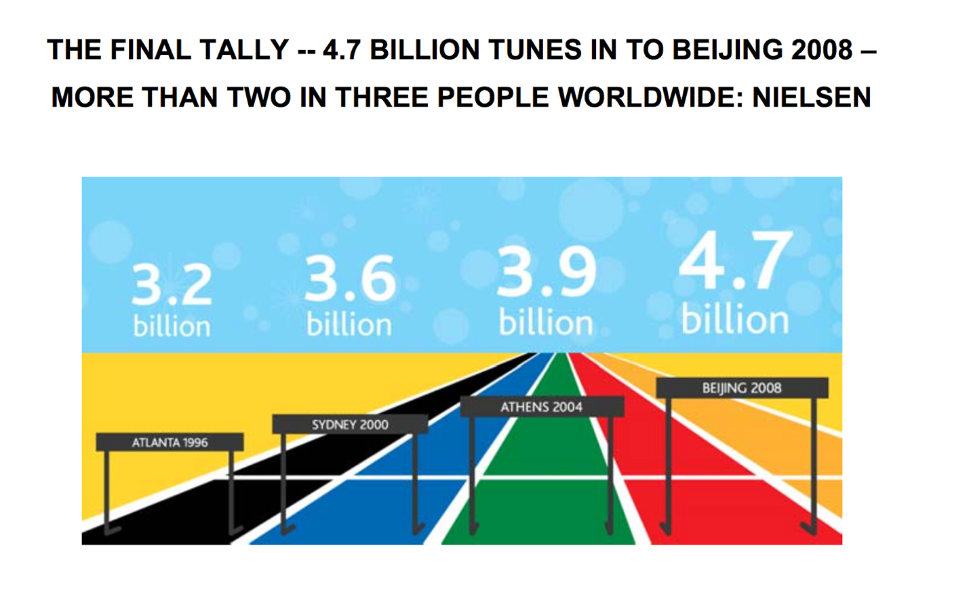

Appendix D

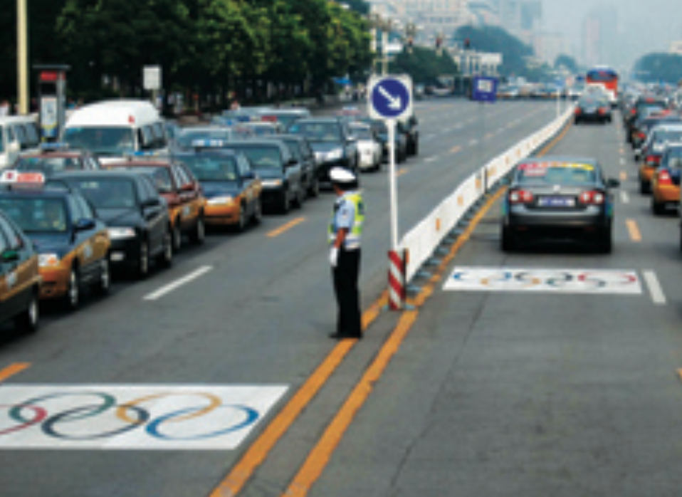

Appendix E

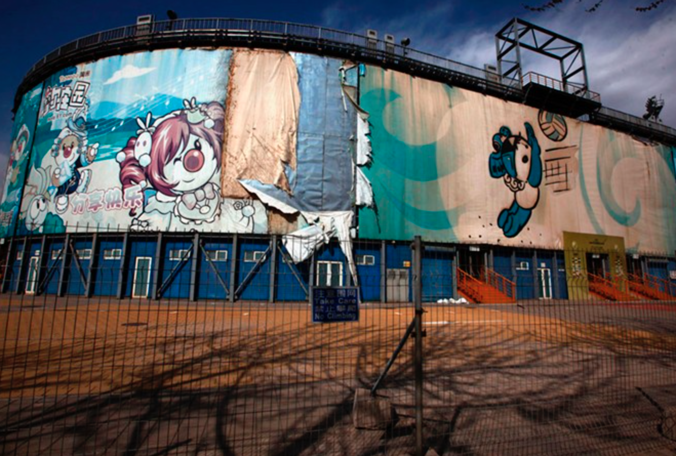

Appendix F

